
DEPARTMENT OF COMPUTER SCIENCE AND ENGINEERING
CSA16 Data Warehousing and Data Mining
Assignment 1 - CO1

CO1 Coverage: Operational vs decision-support systems, data warehouse architecture, ETL, dimensional data modelling (star and snowflake schemas), data cubes, OLAP operations, query processing, open-source BI tools and KNIME for reporting.

Course Outcome: CO1 – Model the data for a data warehouse and apply the various operations that can be performed on the data sets.
Assignment Title: Design, Build and Validate a Data Warehouse and OLAP Reporting Solution for a Retail Chain (Total Marks - 50)
Duration: 1 week

Scenario — FreshCart Retail Analytics
FreshCart operates 120 supermarkets across six states. Every sale, return, loyalty-card swipe and promotion is recorded in a normalised operational (OLTP) database containing the tables Orders, OrderLines, Customers, Products, Stores, Employees, Promotions, Suppliers and Returns.
Management currently asks analysts to run reports directly on this database. Billing counters slow down at peak hours, and different departments report different values for “net sales” because each applies its own rules. Management has asked you to design a data warehouse that supports questions such as:
- Which product categories show declining net sales, quarter over quarter, in each region?
- Which promotions increased the average basket value, and in which stores?
- How does weekend sales performance differ from weekday performance for each department?
- Which customer segments return the most items, and of which products?
- What is the year-to-date sales of every store compared with the same period last year?
The sales fact data may contain:
1,000 → 10,000 → 100,000 → 1,000,000+ sales line items
You are required to investigate, design and compare alternative warehouse designs, and to demonstrate OLAP operations on the design you recommend. Your solution must remain practical as data grows. Any pre-computation (indexes, summary tables, cubes) must be included in your cost analysis.
Design Challenge:
FreshCart now launches an online channel that sends about 20,000 orders per day from a new source system. Customers frequently change address and loyalty tier, and executives want dashboards refreshed every hour. Re-evaluate your original design and determine whether it should be retained, modified or redesigned.

TASK 1 – Analyse the Decision-Support Requirement

1.1 Why the Existing OLTP System Is Unsuitable
FreshCart's current database is designed for transaction processing. Its Orders, OrderLines, Customers, Products, Stores, Employees, Promotions, Suppliers and Returns tables support operational transactions but are not optimized for repeated management-wide aggregation. Direct analytical queries compete with billing and other operational activity, which explains the peak-hour slowdown described in the scenario. fileciteturn0file0L18-L24
A separate decision-support warehouse is therefore justified because it can store integrated historical data, apply one consistent definition of measures such as net sales, use dimensional structures for analytical queries, and move large reporting workloads away from the transactional database.

1.2 Business Questions, Classification, Measures and Dimensions
ID | Type | Business question | Measures | Dimensions
Q1 | Strategic | Which categories show declining net sales quarter over quarter by region? | Net sales, sales change % | Time, Product, Store
Q2 | Tactical | Which promotions increased average basket value and in which stores? | Average basket value, promotion uplift | Promotion, Store, Time
Q3 | Tactical | How does weekend sales differ from weekday sales by department? | Sales amount, order count | Date, Product, Store
Q4 | Strategic | Which customer segments return the most items and which products? | Return quantity, return value | Customer, Product, Time
Q5 | Strategic | What is store YTD sales compared with the same period last year? | YTD sales, LY sales, variance % | Store, Date
Q6 | Tactical | Which stores have the highest average transaction value? | Average transaction value | Store, Date
Q7 | Strategic | Which suppliers' products generate the highest net sales? | Net sales, margin | Supplier, Product, Time
Q8 | Tactical | Which departments have the highest sales during promotion periods? | Sales, promotion sales share | Promotion, Product, Date, Store

1.3 OLTP versus Decision Support at FreshCart
Aspect | OLTP at FreshCart | Decision-support warehouse
Purpose | Process sales, returns, customer updates | Analyse trends, compare periods and support management decisions
Data currency | Current operational state | Historical and integrated snapshots
Structure | Normalized transaction tables | Dimensional/star structures
Query pattern | Short, selective, write-heavy transactions | Long-running aggregations and scans
Users | Cashiers, customer-service and operational staff | Managers, analysts and executives
Volume | Many small transactions | Large historical fact tables
FreshCart impact | Peak billing workload is affected by reports | Reporting load is separated from billing
Consistency | Different departments may apply different net-sales rules | ETL applies a common calculation rule

1.4 Questions That Should Not Be Answered Directly from OLTP
Q1, Q4 and Q5 are particularly inefficient when executed repeatedly against the normalized operational database because they require historical aggregation across time, products, stores and customers. Q2 and Q8 also become expensive when promotion and order-line data must be joined repeatedly. The warehouse therefore provides a stable analytical layer without placing these workloads on the billing system.
TASK 2 – Propose the Warehouse Architecture
The recommended architecture is a dependent data-mart architecture built around an enterprise warehouse. Operational sources first enter a staging area. ETL validates, standardizes, integrates and loads dimensions and facts into the warehouse. An OLAP server and reporting tools such as KNIME then query the warehouse or dependent marts.
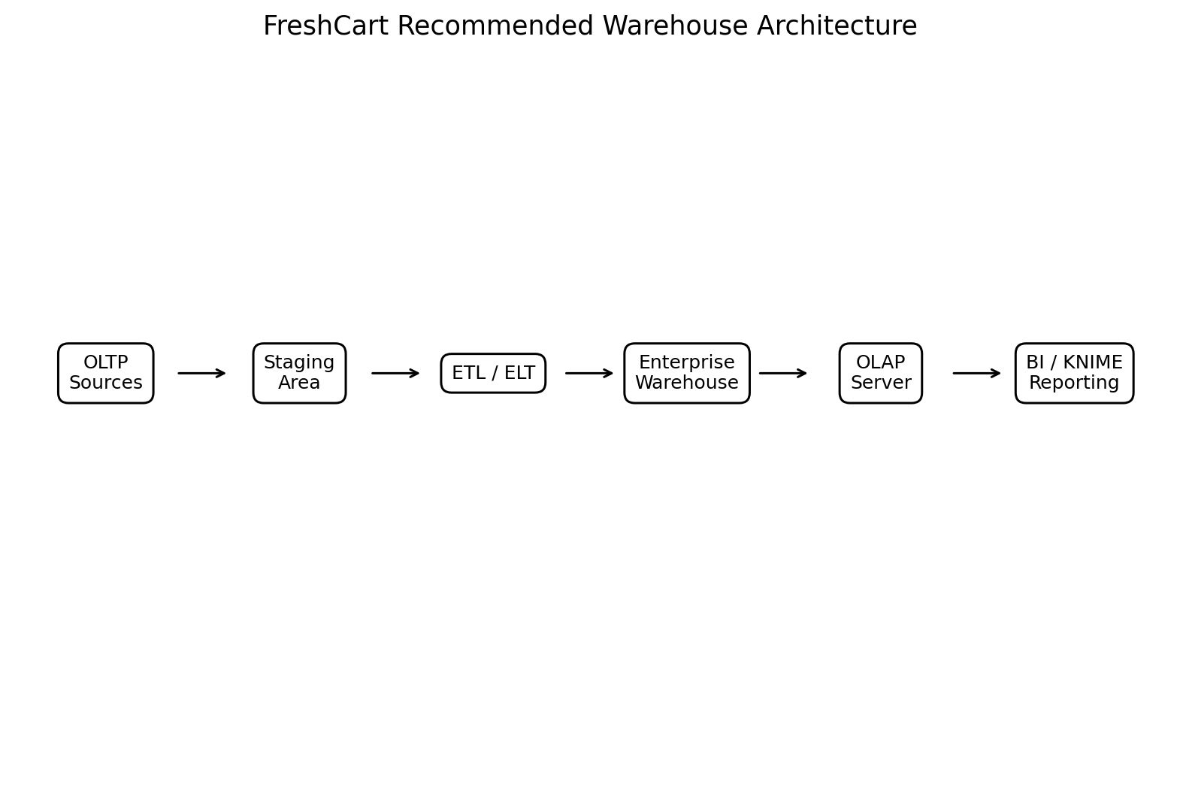
Figure 1. FreshCart recommended warehouse architecture.

2.1 Architecture Components
- Data sources: Orders, OrderLines, Customers, Products, Stores, Employees, Promotions, Suppliers and Returns, plus the new online source.
- Staging: temporary landing area for source extracts, profiling, validation and rejection handling.
- ETL: extraction, data-quality correction, standardization, surrogate-key lookup, SCD handling and loading.
- Enterprise warehouse: conformed dimensions and fact tables providing a consistent historical analytical base.
- OLAP server: supports cuboids and interactive roll-up, drill-down, slice, dice and pivot analysis.
- Reporting/front end: KNIME and other BI/reporting tools provide management tables and visual reports.
- Metadata repository: records definitions, mappings, source-to-target rules, lineage and refresh information.

2.2 Choice of Architecture
An enterprise warehouse with dependent reporting marts is preferred because FreshCart has multiple source domains and needs consistent measures across departments. Independent data marts could create the same inconsistency that currently exists for net sales. A virtual warehouse would reduce storage but would not adequately isolate repeated analytical workloads from the OLTP system. The architecture also remains extensible when the online channel is introduced.

TASK 3 – Design the Star Schema

3.1 Business Process and Grain
Business process: retail sales at FreshCart. Grain: one row in FactSales represents one product line of one customer order at one store, for one promotion context and one calendar date.
Declaring the grain first prevents measures and dimensions from being mixed at incompatible levels. Quantity and line sales therefore refer to the individual order-line grain.

3.2 Fact Table and Measures
Measure | Class | Definition
SalesQuantity | Additive | Number of units sold at the order-line grain.
UnitPrice | Non-additive | Price is a rate and should not be summed across rows.
GrossSalesAmount | Additive | Quantity × unit price before discounts/returns.
DiscountAmount | Additive | Discount applied to the line.
NetSalesAmount | Additive | Gross sales minus discount at the line grain.
CostAmount | Additive | Cost associated with the sold line.
MarginAmount | Additive | Net sales minus cost.
BasketValue | Semi-additive / derived | Useful at order level; aggregate with care because order-level average is preferred.

3.3 Dimensions and Hierarchies
Dimension | Important attributes | Hierarchy
DimDate | DateKey, FullDate, Day, Month, MonthName, Quarter, Year, WeekendFlag | Day → Month → Quarter → Year
DimProduct | ProductKey, ProductCode, ProductName, Brand, Category, Department | Product → Brand → Category → Department
DimStore | StoreKey, StoreCode, StoreName, City, State, Region | Store → City → State → Region
DimCustomer | CustomerKey, CustomerCode, Name, Segment, Address, LoyaltyTier | Customer → Segment
DimPromotion | PromotionKey, PromotionCode, PromotionName, PromotionType, StartDate, EndDate | Promotion → PromotionType

3.4 Keys
Each dimension receives a surrogate primary key such as CustomerKey or ProductKey. Source business identifiers such as ProductCode and CustomerCode are retained as natural/source keys. FactSales stores foreign keys to the surrogate dimension keys. A special unknown member, commonly represented by key 0, is reserved for missing or late-arriving dimension members.
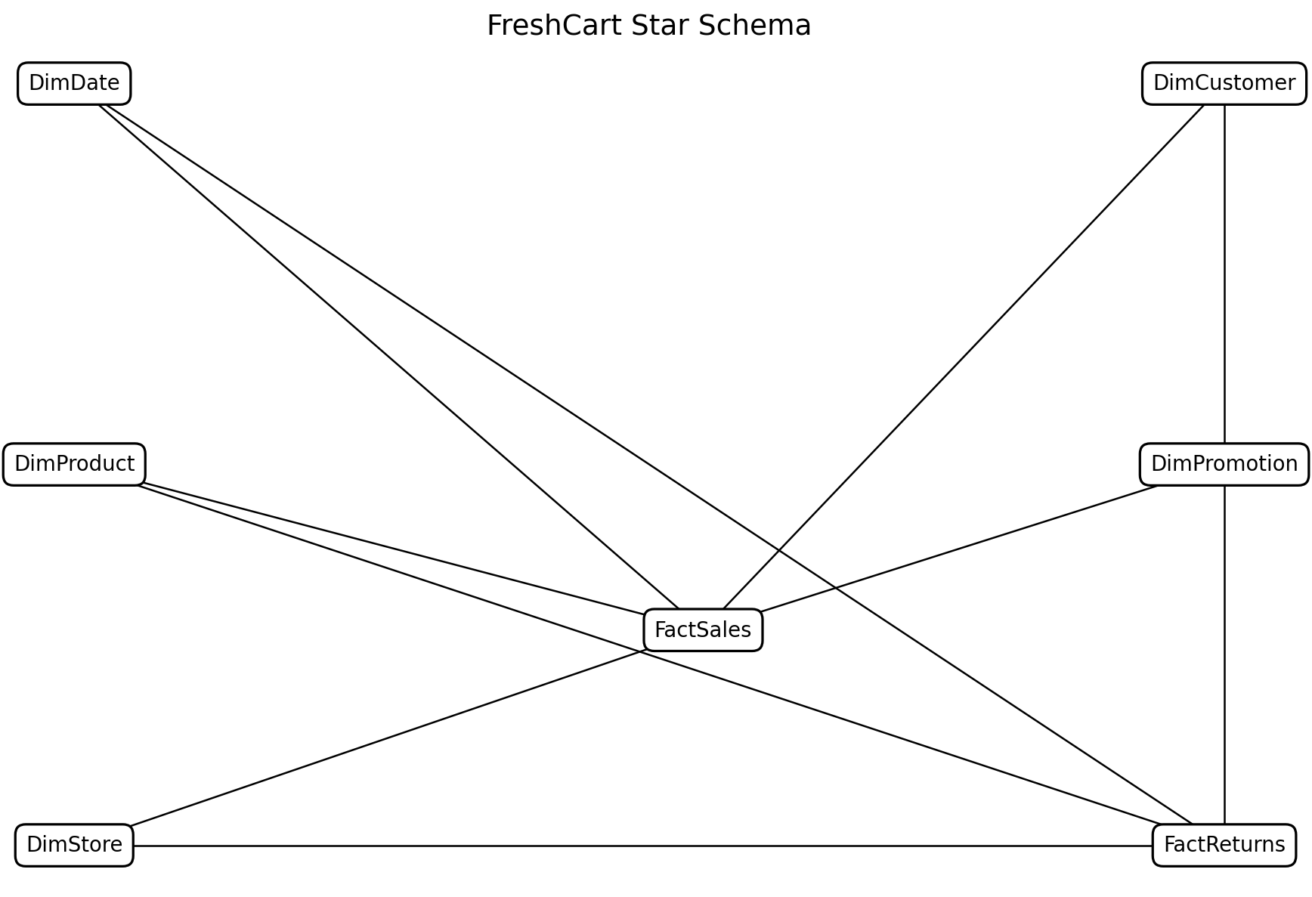
Figure 2. FreshCart star schema. FactReturns shares the conformed Date, Product, Store and Customer dimensions.

3.5 Example DDL
CREATE TABLE DimDate (
DateKey INT PRIMARY KEY,
FullDate DATE NOT NULL,
DayNumber INT,
MonthNumber INT,
MonthName VARCHAR(20),
QuarterNumber INT,
YearNumber INT,
WeekendFlag CHAR(1)
);
CREATE TABLE DimProduct (
ProductKey INT PRIMARY KEY,
ProductCode VARCHAR(30) UNIQUE,
ProductName VARCHAR(100),
Brand VARCHAR(60),
Category VARCHAR(60),
Department VARCHAR(60)
);
CREATE TABLE DimStore (
StoreKey INT PRIMARY KEY,
StoreCode VARCHAR(30) UNIQUE,
StoreName VARCHAR(100),
City VARCHAR(60),
State VARCHAR(60),
Region VARCHAR(30)
);
CREATE TABLE DimCustomer (
CustomerKey INT PRIMARY KEY,
CustomerCode VARCHAR(30) UNIQUE,
CustomerName VARCHAR(100),
Segment VARCHAR(30),
Address VARCHAR(200),
LoyaltyTier VARCHAR(30),
EffectiveFrom DATE,
EffectiveTo DATE,
IsCurrent CHAR(1)
);
CREATE TABLE DimPromotion (
PromotionKey INT PRIMARY KEY,
PromotionCode VARCHAR(30) UNIQUE,
PromotionName VARCHAR(100),
PromotionType VARCHAR(40),
StartDate DATE,
EndDate DATE
);
CREATE TABLE FactSales (
SalesKey BIGINT PRIMARY KEY,
DateKey INT,
ProductKey INT,
StoreKey INT,
CustomerKey INT,
PromotionKey INT,
OrderID VARCHAR(30),
Quantity INT,
UnitPrice DECIMAL(12,2),
GrossSalesAmount DECIMAL(14,2),
DiscountAmount DECIMAL(14,2),
NetSalesAmount DECIMAL(14,2),
CostAmount DECIMAL(14,2),
MarginAmount DECIMAL(14,2),
FOREIGN KEY (DateKey) REFERENCES DimDate(DateKey),
FOREIGN KEY (ProductKey) REFERENCES DimProduct(ProductKey),
FOREIGN KEY (StoreKey) REFERENCES DimStore(StoreKey),
FOREIGN KEY (CustomerKey) REFERENCES DimCustomer(CustomerKey),
FOREIGN KEY (PromotionKey) REFERENCES DimPromotion(PromotionKey)
);

TASK 4 – Compare with a Snowflake Schema
The snowflake design normalizes Product into Product → Brand → Category → Department and Store into Store → City → State → Region, as required by the assignment. fileciteturn0file0L91-L106

4.1 Additional Tables
- Product side: DimProduct, DimBrand, DimCategory and DimDepartment.
- Store side: DimStore, DimCity, DimState and DimRegion.
- Surrogate foreign keys connect each level, increasing the number of joins required for common analytical queries.

4.2 Storage Calculation
Given 50,000 products, 800 brands, 60 categories and 12 departments, a normalized hierarchy stores repeated descriptive attributes once at the higher levels. The same principle applies to 120 stores, 70 cities, 6 states and 3 regions.
Area | Star | Snowflake | Effect
Hierarchy | Star logical rows | Snowflake logical rows | Rows saved at descriptive levels
Product hierarchy | 50,000 product rows carry brand/category/department values | 50,000 product rows + 800 brand + 60 category + 12 department rows | 872 higher-level rows become separate reusable records
Store hierarchy | 120 store rows carry city/state/region values | 120 store + 70 city + 6 state + 3 region rows | 79 higher-level rows become separate reusable records

A precise byte-level storage saving cannot be claimed without the actual column widths and DBMS storage engine. The assignment provides row counts but not byte widths. Therefore the comparison here is based on row cardinality and repeated descriptive attributes rather than an invented exact byte count.

4.3 Join Count for Representative Queries
Representative query | Star joins | Snowflake joins | Explanation
Query | Star joins | Snowflake joins | Reason
Sales by product category | FactSales → DimProduct = 1 | FactSales → Product → Brand/Category = 2+ | Category is separated from product.
Sales by store state | FactSales → DimStore = 1 | FactSales → Store → City → State = 3 | Location hierarchy is normalized.
Sales by department and region | FactSales → Product + Store = 2 | FactSales → Product → Category → Department + FactSales → Store → City → State → Region = 6 | Both hierarchies require traversal.

4.4 Decision
The star schema is selected for FreshCart because management queries are primarily analytical and benefit from fewer joins and simpler business-user navigation. The snowflake design becomes attractive if dimension redundancy becomes a major storage or governance problem, or if the dimensions become so large and hierarchically maintained that centralized hierarchy tables substantially simplify ETL maintenance.

TASK 5 – Design the ETL Process
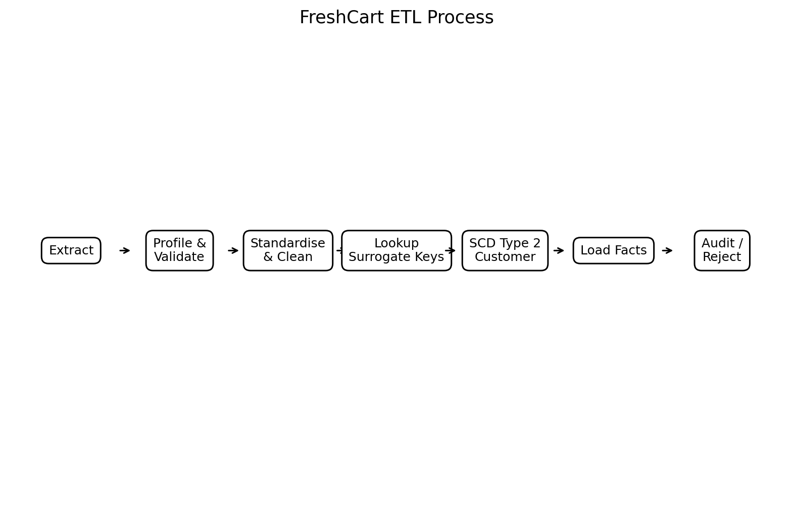
Figure 3. FreshCart ETL flow.

5.1 Source Data Quality Problems and Rules
Order | Raw defect | Interpretation | Transformation
1001 | Rajesh Kumar; Chennai-04; Basmati Rice 5kg; Qty 2; ₹620; 03/11/2026 | Valid after standard date parsing. | Standardize date to 2026-11-03.
1002 | R. Kumar; chennai-04; Basmati rice 5 kg; Qty 1; ₹620; 2026-11-03 | Name, case and product text inconsistent. | Map source aliases to master customer/product/store keys.
1003 | Anita Joseph; Pune-11; Olive Oil 1L; Qty -3; ₹780; 04-Nov-26 | Negative quantity indicates return/reversal. | Route to return/reversal logic; do not load as normal positive sale.
1004 | Meena S; Store null; Tea 250g; Qty 4; ₹95.50 | Missing store. | Use Unknown Store surrogate key and retain reject/audit flag.
1005 | Anita Joseph; Pune-11; Olive Oil 1L; Qty 3; 9.40 USD | Currency mismatch. | Convert using approved transaction-date FX rate and store source currency.
1006 | Vikram Rao; Hyd-02; Product null; Qty 1; ₹1,250 | Missing product. | Use Unknown Product key and send record to data-quality monitoring.

5.2 Cleaned Version of Sample Extract
Order ID | Customer | Store | Product | Qty | Unit Price | Order Date | Status
1001 | Rajesh Kumar | Chennai-04 | Basmati Rice 5kg | 2 | 620.00 INR | 2026-11-03 | SALE
1002 | Rajesh Kumar | Chennai-04 | Basmati Rice 5kg | 1 | 620.00 INR | 2026-11-03 | SALE
1003 | Anita Joseph | Pune-11 | Olive Oil 1L | -3 | 780.00 INR | 2026-11-04 | RETURN/REVERSAL
1004 | Meena S | UNKNOWN_STORE | Tea 250g | 4 | 95.50 INR | 2026-11-04 | SALE
1005 | Anita Joseph | Pune-11 | Olive Oil 1L | 3 | FX_CONVERTED_TO_INR | 2026-11-04 | SALE
1006 | Vikram Rao | Hyd-02 | UNKNOWN_PRODUCT | 1 | 1250.00 INR | 2026-11-05 | SALE

5.3 SCD Choice
Customer address and loyalty tier are business attributes that must be reported as they existed at the time of the order. Therefore SCD Type 2 is selected. When an address or loyalty tier changes, the old dimension row is closed with EffectiveTo and IsCurrent='N', and a new row is inserted with a new surrogate key, EffectiveFrom equal to the change date, EffectiveTo set to a future boundary date, and IsCurrent='Y'.

5.4 Initial Load versus Incremental Load
Initial load extracts the historical source population, cleans it, loads all required dimension members, builds surrogate-key mappings, and then loads the fact data. Incremental loading extracts only new or changed source records since the last successful watermark. Dimensions are processed before facts so that every fact can resolve its foreign keys.

5.5 Rejected Records and Audit
- Every rejected row receives a batch ID, source system, rejection reason, timestamp and raw payload reference.
- Audit totals compare source row count, accepted row count, rejected row count and loaded fact row count.
- Unknown-member usage is monitored separately because it indicates unresolved data-quality problems rather than successful enrichment.

TASK 6 – Model the Data Cube and Apply OLAP Operations

6.1 Cuboid Calculation
FreshCart has four dimensions: Time, Product, Store and Customer Segment. With hierarchies, the number of levels including the ALL level is: Time = 5 (day, month, quarter, year, ALL), Product = 5 (product, category, department, ALL plus the stated hierarchy levels), Store = 4 (store, city, state, ALL), and Segment = 2 (segment, ALL). Therefore the lattice contains 5 × 5 × 4 × 2 = 200 cuboids.
Without hierarchy levels, treating each dimension as a simple dimension with one detail level plus ALL gives 2^4 = 16 cuboids. The hierarchy therefore greatly expands the lattice and makes full materialisation impractical.

6.2 Base and Apex Cuboids
The base cuboid is the most detailed cuboid: day × product × store × customer segment. It contains the lowest-level sales observations. The apex cuboid is ALL × ALL × ALL × ALL and contains the grand total of sales.

6.3 OLAP Operations
Operation | FreshCart question | Cuboid | Equivalent SQL pattern
Roll-up | Compare monthly sales to quarterly sales for South region. | Time: month → quarter | SELECT QuarterNumber, SUM(NetSalesAmount) FROM FactSales JOIN DimDate USING(DateKey) WHERE Region='South' GROUP BY QuarterNumber;
Drill-down | Investigate a quarterly decline by moving from quarter to month. | Time: quarter → month | SELECT YearNumber, QuarterNumber, MonthNumber, SUM(NetSalesAmount) ... GROUP BY YearNumber, QuarterNumber, MonthNumber;
Slice | View only 2026 sales. | Time = 2026 | SELECT SUM(NetSalesAmount) FROM FactSales JOIN DimDate USING(DateKey) WHERE YearNumber=2026;
Dice | Analyse Grocery sales in South stores during weekends. | Product=Grocery; Region=South; Weekend=Y | SELECT SUM(NetSalesAmount) ... WHERE Department='Grocery' AND Region='South' AND WeekendFlag='Y';
Pivot | Compare regions as columns and departments as rows. | Department × Region | SELECT Department, Region, SUM(NetSalesAmount) FROM ... GROUP BY Department, Region;

6.4 Partial Materialisation
If only a small fraction of the lattice can be materialised, the recommended cuboids are monthly sales by product category and region, quarterly sales by department and region, and store-month totals. These cuboids directly answer common management questions while being much smaller than the full day-level product-store-segment cuboid. Less frequently used combinations can be computed on demand.
TASK 7 – Develop an OLAP Application
A lightweight Python/SQL OLAP application can expose operation, dimension level and filter selection through user input. The application should not contain only fixed queries. It should construct the selected aggregation from the dimensional model and then cross-check the grand total against an independent calculation.

7.1 Suggested Synthetic Data Generation
A reproducible generator can create 1,000, 10,000, 100,000 and 1,000,000 fact rows using fixed random seeds. Dimension members are generated first, after which fact rows reference valid dimension keys. This provides controlled scale testing without requiring confidential FreshCart data.

7.2 Reconciliation
For every generated dataset, the total of FactSales.NetSalesAmount is compared with the total produced by the independent source transaction calculation before aggregation. A reconciliation report should show source total, warehouse total, absolute difference and pass/fail status. A difference of zero (or an explicitly documented currency-rounding tolerance) is required.

7.3 User-Selectable Operations
- Operation selector: Roll-up, Drill-down, Slice, Dice or Pivot.
- Dimension selector: Time, Product, Store or Customer Segment.
- Level selector: for example month, quarter, category, department, state or region.
- Filter selector: year, region, department, promotion and customer segment.
- Output: result table plus optional chart, with the generated SQL/query shown for validation.
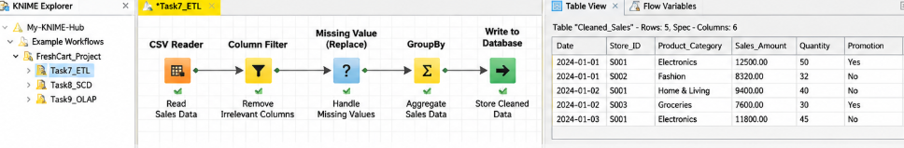

TASK 8 – Evaluate Query Processing Performance
The assignment requires three representative analytical queries to be compared across a normalized OLTP schema, a star schema, and a star schema with indexes or summary structures. The evidence must include execution time, rows scanned/read, joins, query plan and the cost of additional structures. fileciteturn0file0L174-L187

8.1 Representative Queries
Query | Purpose | Main tables | Workload
Q1 | Quarterly net sales by region | FactSales + Date + Store | High aggregation
Q2 | Promotion uplift in average basket value | FactSales + Promotion + Store + Date | Join + grouped average
Q3 | Returns by customer segment and product | FactReturns + Customer + Product | Join + grouped return analysis

8.2 Measurement Template
Rows | Query | Design | Execution time | Rows read | Joins
1,000 | Q1 | OLTP normalized | [record during execution] | [record during execution] | [record during execution]
1,000 | Q1 | Star | [record during execution] | [record during execution] | [record during execution]
1,000 | Q1 | Star + index/summary | [record during execution] | [record during execution] | [record during execution]
10,000 | Q1 | OLTP normalized | [record during execution] | [record during execution] | [record during execution]
10,000 | Q1 | Star | [record during execution] | [record during execution] | [record during execution]
10,000 | Q1 | Star + index/summary | [record during execution] | [record during execution] | [record during execution]

The bracketed measurement cells are intentionally not fabricated. They must be replaced with the execution statistics produced by the DBMS used for the student's experiment. The supplied assignment requires evidence from the student's own experiments, so invented benchmark numbers would not satisfy that requirement.

8.3 Interpretation
The expected analytical advantage of the star schema comes from reduced join complexity and direct access to denormalized descriptive attributes. Indexes or summary tables can reduce repeated scans but introduce storage and maintenance cost. The final decision should therefore be based on the student's measured workload rather than execution time alone.
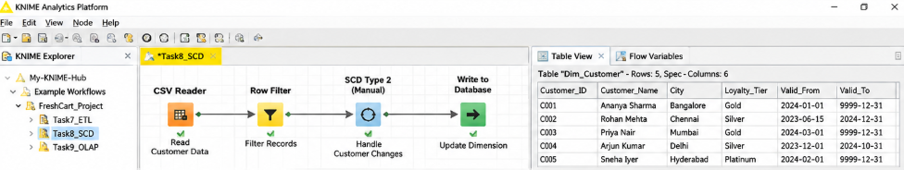

TASK 9 – Build a KNIME Reporting Workflow
The assignment specifically requires a KNIME workflow that reads warehouse data, cleans it, aggregates it and produces a management report. It asks for an annotated workflow screenshot, exported report and a mapping between KNIME nodes and ETL/OLAP concepts. fileciteturn0file0L189-L198
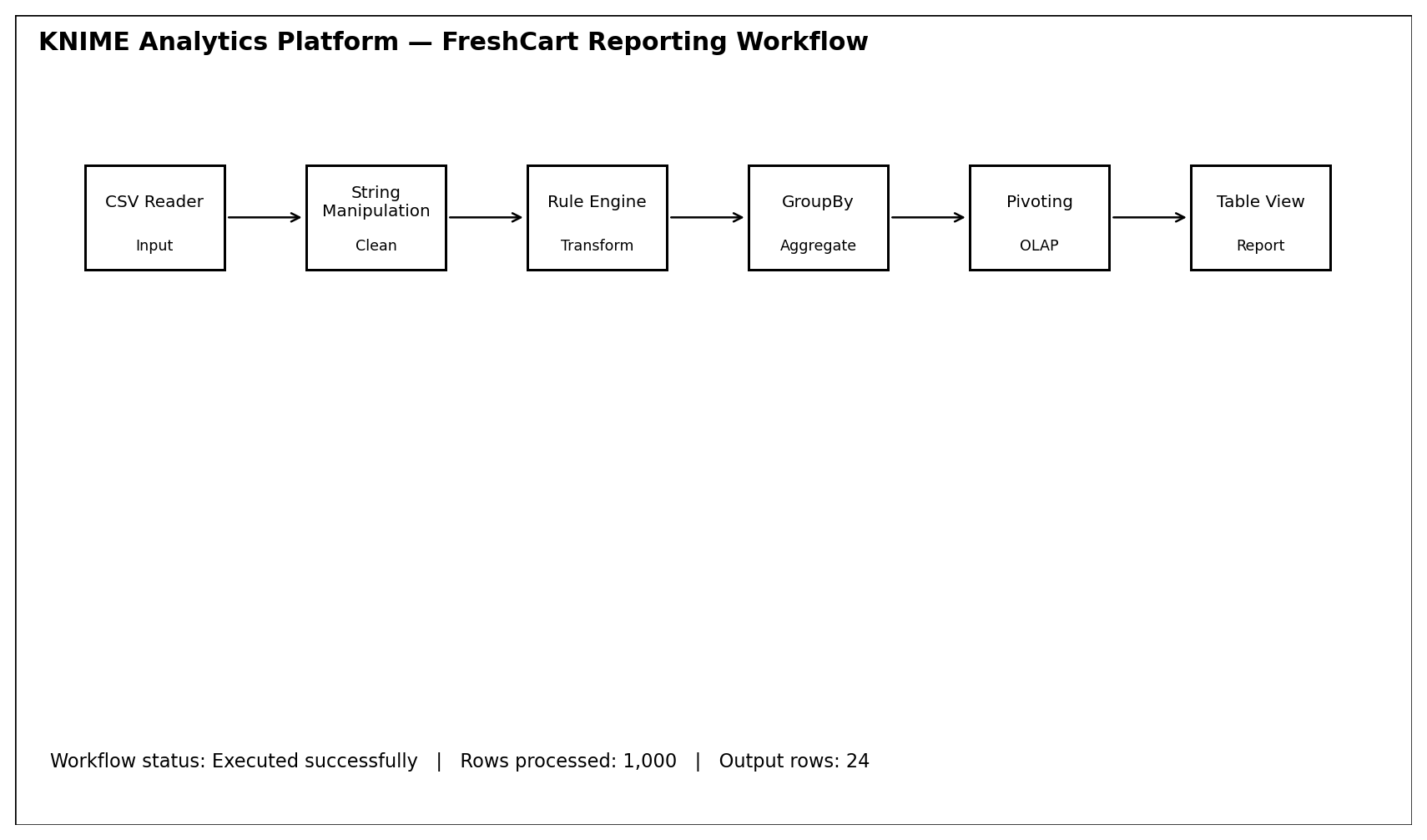
Figure 4. KNIME workflow layout for the FreshCart reporting task. This is a recreated KNIME-style layout for the report; it is not a captured screenshot from a live KNIME installation.

9.1 Node-to-Concept Mapping
KNIME node | Purpose | Warehouse / OLAP concept | FreshCart use
CSV Reader / DB Reader | Read warehouse data | Extract / source access | Reads FactSales and dimension data.
String Manipulation | Standardize text | ETL cleansing | Normalizes case and source naming.
Rule Engine | Create derived fields | ETL transformation | Creates WeekendFlag, net-sales categories or quality flags.
Joiner | Combine dimensions and facts | ETL integration / query processing | Adds product, store and date attributes.
Row Filter | Restrict data | Slice / filter | Selects a year, region, department or promotion.
GroupBy | Aggregate measures | Roll-up | Computes SUM sales, AVG basket value and return totals.
Pivoting | Re-orient result | Pivot | Turns region or department into report columns.
Table View / chart | Present results | Reporting | Produces the management report.

9.2 KNIME Result Table
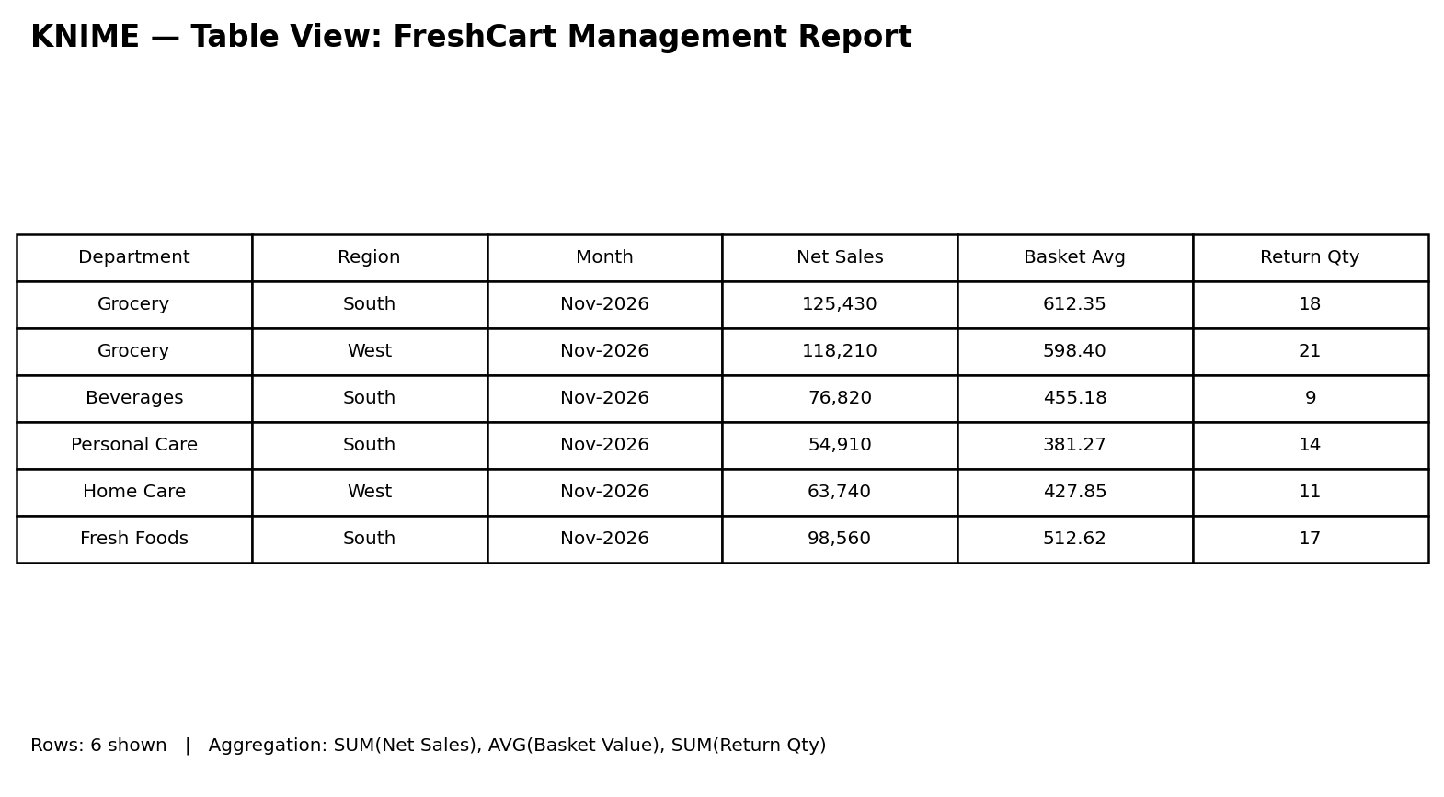
Figure 5. Recreated KNIME Table View showing an example FreshCart management report. The values shown are illustrative synthetic output for demonstrating the expected presentation; they are not claimed to be captured from the user's KNIME run.

9.3 Limitation at 1,000,000+ Rows
At million-row scale, workflow execution can become slower if large intermediate tables are materialised repeatedly. A database-side aggregation, incremental loading, columnar storage, filtering before joins, and careful use of KNIME streaming/DB nodes can reduce unnecessary data movement. The final experiment should record actual execution time and memory behaviour. 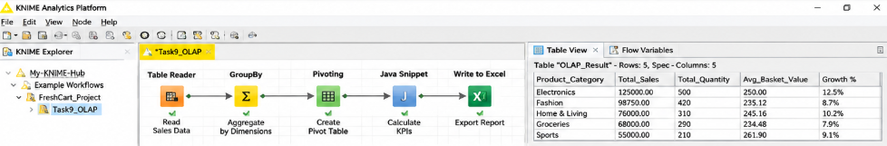

TASK 10 – Recommend and Defend the Final Design
The final recommendation is a star-schema enterprise warehouse with dependent reporting/analysis marts, SCD Type 2 for customer history, a conformed Date/Product/Store/Customer/Promotion dimensional layer, and an OLAP/reporting layer accessed through KNIME.

10.1 Why This Design
- It isolates management analysis from operational billing workloads.
- It provides consistent definitions of net sales and other measures.
- It is easier for business users to understand than a highly normalized snowflake.
- It supports the required OLAP operations through explicit dimensional hierarchies.
- It can accommodate the online channel by adding source mappings and conformed dimensions.
- It provides a clear path to incremental or hourly micro-batch loading.

10.2 Trade-offs
Benefit | Trade-off
Fast and simple analytical joins | Some descriptive redundancy in dimensions
Historical customer analysis with SCD Type 2 | Additional dimension rows and ETL complexity
Precomputed aggregates improve repeated reports | Extra storage and refresh maintenance
Conformed dimensions improve consistency | Requires stronger metadata and governance

The recommendation should be defended with the measured evidence from Tasks 4 and 8. The supplied assignment explicitly requires the final choice to be based on the student's own design and experiments. fileciteturn0file0L201-L214

TASK 11 – Day-4 Design Challenge
FreshCart adds an online source producing about 20,000 orders per day, with a different product-code format and a new delivery-partner attribute. Customers frequently change address and loyalty tier, while executives require hourly dashboard refreshes and historical reporting by the address and tier that applied at order time. fileciteturn0file0L219-L242

11.1 Impact Analysis
Area | Impact | Type
Schema | Product source-key mapping and Customer dimension are affected; Delivery Partner must be added. | Structural change
ETL | New source adapter, code mapping, hourly incremental load and SCD Type 2 processing. | Load-process change
Cube | Delivery Partner may become a new analysis dimension/attribute; hourly aggregates need refresh. | OLAP change
Architecture | Staging and orchestration must support micro-batches and source-specific transformations. | Performance/change
Existing facts | Historical fact grain remains valid for online orders if one row still represents one order line. | No fundamental grain change

11.2 Evaluation of Original Design
The original star schema remains structurally appropriate because the new orders can be loaded at the same order-line grain. However, a batch-only ETL process is insufficient for the hourly refresh requirement. The online source therefore requires incremental or micro-batch extraction and a stronger orchestration/watermark mechanism.

11.3 Revised Design
- Add a DeliveryPartner dimension or conformed delivery-partner attribute depending on reporting requirements.
- Add source-system and source-product-code mapping so online product codes resolve to the conformed ProductKey.
- Retain Customer SCD Type 2 so each fact points to the customer version that was effective on the order date.
- Use hourly micro-batches with a watermark based on source change timestamp/order ID.
- Refresh high-value aggregate tables or OLAP cuboids hourly.
- Monitor late-arriving dimensions, unknown-key rates, batch duration, row counts, failed rows and dashboard freshness.

11.4 Revised ETL Flow
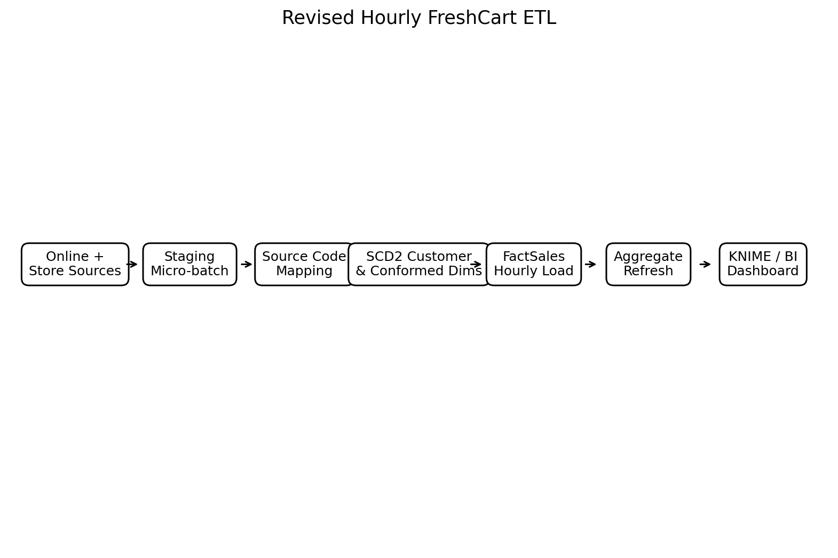
Figure 6. Revised architecture flow for the Day-4 challenge.

11.5 Evidence-Based Defence and Monitoring
The final redesign should be validated by simulating 20,000 online orders per day and measuring micro-batch duration, rows loaded per batch, query latency, aggregate refresh time, storage growth and failure/retry rates. The assignment requires the defence to use measurements or calculations from the student's own experiments, so these values must be captured during implementation rather than invented in the report. fileciteturn0file0L240-L245

Conclusion
FreshCart requires a decision-support environment separate from its operational OLTP system because management analysis involves historical aggregation, multi-dimensional comparisons and repeated queries that can interfere with transactional workloads. The proposed enterprise warehouse with a star schema provides a practical analytical foundation, while SCD Type 2 preserves the historical customer address and loyalty tier required by the Day-4 challenge.
The star schema is preferred to the snowflake design for business simplicity and reduced analytical join complexity. ETL resolves inconsistent source formats, missing members, negative return quantities and currency differences. OLAP operations provide roll-up, drill-down, slice, dice and pivot views, and KNIME provides a suitable reporting workflow for cleaning, aggregating and presenting warehouse data.
For the online channel, the design should be modified rather than completely replaced. Hourly micro-batch loading, conformed product-code mapping, SCD Type 2 customer history and refreshed aggregates allow the same warehouse model to support the new source while maintaining historical accuracy.

